VERIFIED - In vivo patient-specific real-time dosimetry for adaptive radiotherapy
Project objectives and goals
The primary objective of the VERIFIED project is to develop dynamic end-to-end methods that closely simulate real patient treatments. Our project encompasses several key objectives. First, it involves the development and characterization of appropriate phantoms featuring movable and deformable inserts, specifically targeting lung and brain tumors for ART. Additionally, we focus on investigating individualized patient-specific real-time dosimetry in cases of non-small-cell lung cancer using Volumetric Modulated Arc Therapy (ART-VMAT).
This approach enables accurate and timely monitoring of radiation doses. development of a real-time dose prediction protocol for non-small-cell lung and bladder tumors ART-VMAT. This protocol combines data obtained from the developed dynamic phantoms and the patient-specific real-time dosimetry system. Deep learning algorithms are employed to enhance the accuracy of dose prediction. Furthermore, an image-based system is being implemented to monitor the patient's head surface during in adaptive hypofractionated Gamma Knife radiosurgery (hfGKRS) for brain tumors, ensuring precise treatment delivery.
Additionally, we will analyze the data obtained from the patient's head surface monitoring system, incorporating deep learning-based algorithms to generate a protocol for patient selection in hfGKRS.The proposed protocols integrate state-of-the-art deep learning methods with patient specific real-time dosimetry in ART-VMAT and real-time position imaging in hfGKRS, effectively addressing several unmet needs in adaptive radiotherapy.
These protocols encompass adaptability assessment, dosimetric verification, imaging validation, plan evaluation metrics, and treatment efficiency. By leveraging the power of real-time dosimetry, imaging, and deep learning, treatment efficacy can be enhanced while minimizing toxicity and radiation-induced side effects, ultimately resulting in improved patient outcomes in radiotherapy.
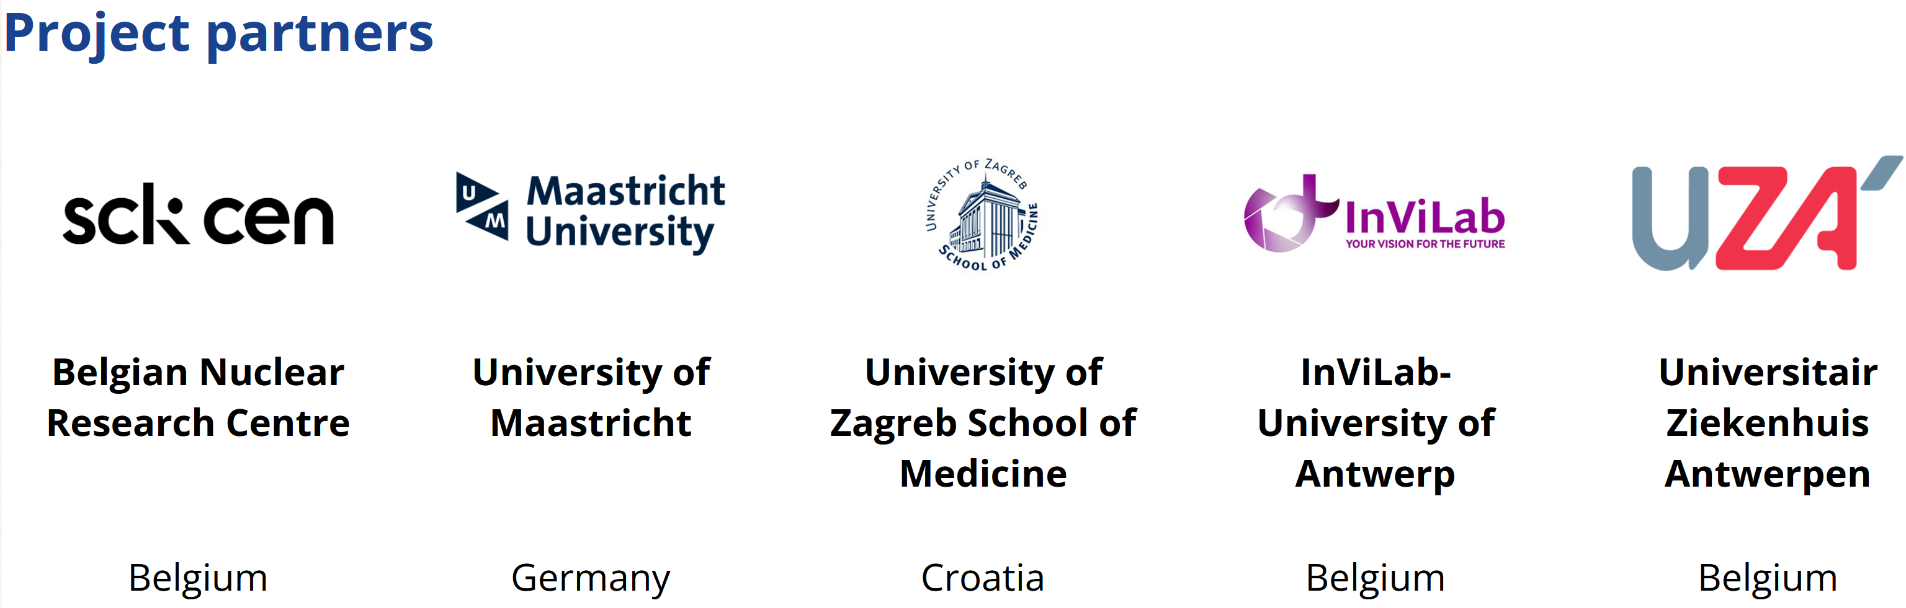

VERIFIED Symposium – 11th of September, 2025

Open Symposium (public)
Time | Session | Speakers | Purpose
08:30 – 09:00 | Registration & coffee |  | Posters showing project goals & partner logos
09:00 – 09:15 | Welcome & Symposium overview | Dr Luana de Freitas Nascimento, SCK CEN | Brief project story and glossary slide.
09:15 – 10:30 | Keynote: “Adaptive radiotherapy– where are we and where do we need to go?” | Prof. dr. M. Machiels – oncologist, ZAS hospital  Prof dr. Dirk Verellen – medical physics, ZAS hospital  Prof. dr. Hrvoje Hršak – medical physics, KBC hospital, Croatia | 3×20 min talks + Q&A: Set the clinical stage; combine clinical experiences
10:30 – 11:00 | Coffee break |  | Posters
11:00 – 11:30 | SONORA* talks | SONORA - Prof. dr. Hrvoje Brkic, Croatia | 2×15 min talks
11:30 – 12:00 | Talk block 1 – Technology foundations | Dr. Luana de Freitas Nascimento (SCK CEN) & Prof. dr. Gariel Fonseca (UM) | 2×15 min talks
12:00 – 12:30 | Talk block 2 – Imaging & AI for ART | Prof. dr. Steve Vanlanduit (InViLab) & Dr. Luana de Freitas Nascimento (SCK CEN) | 2×15 min talks
12:30 – 13:00 | Panel Q&A | Morning speakers
13:00 – 14:00 | Walking Lunch | Sandwiches
14:00 – 14:30 | Practical demos – cameras | Prof. dr. Steve Vanlanduit, Dr. Thomas de Kerf (InViLab) & Dr. Luana de Freitas Nascimento (SCK CEN) | Two groups
14:30 – 15:00 | Practical demos – 3D printing | Tim Stessens, Prof. dr. Gariel Fonseca (UM) & Prof. dr. Hrvoje Brkic, Croatia | Two groups
15:00 – 15:45 | Coffee break |  | Posters
15:45 – 16:00 | Walking transfer to Sint‑Augustinus Hospital
16:00 – 16:45 | Clinical visit (after 16:00) | GZA/MIPRO physicists & neurosurgeons
16:45 – 17:15 | Round‑up discussion | Prof dr. Steve Vanlanduit and Prof dr. Hrvoje Hrsak | Collect feedback
17:15 – 17:30 | Closing remarks | Dr. Luana de Freitas Nascimento | closed meeting.
18:30 – 20:30 | Reception | —
* The SONORA project: Towards safe, optimized and personalized radiology and radiotherapy procedures for pregnant patients (PIANOFORTE 2013-015) - In case of Diagnostic and Interventional Radiology (DIR) procedures and Radiotherapy (RT) treatments during pregnancy, the fetal dose must be assessed and optimized. However, the lack of harmonization of clinical practice results in large differences in fetal dose estimation. The SONORA project aims: 1. to develop phantoms of different pregnancy stages; 2. to investigate fetal doses and dosimetry methods for different DIR procedures, RT techniques and patient anatomies; 3. to identify the factors that affect the fetal dose estimations in methods used in clinical practice; 4. to develop and test a clinical tool for estimating the fetal doses in proton RT according to the individual pregnant patient’s anatomy and clinical plan parameters.
Project coordinator - Hrvoje Brkić, J. J. Strossmayer University of Osijek and Faculty of Dental Medicine and Health, Croatia

